IMPERIAL COLLEGE LONDON
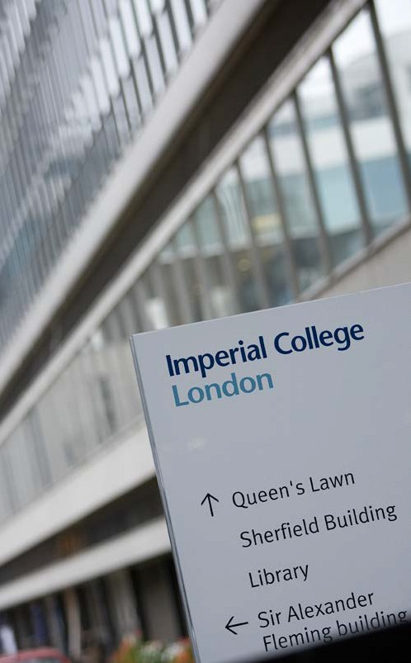
Further Particulars

Imperial College London is one of the world’s leading science-focused universities, committed to making advances in research and education for the benefit of society.

Multi-cultural, global in outlook and reach, Imperial consistently achieves high ranking nationally and internationally.

The College has three faculties: Engineering, Medicine and Natural Sciences, a Business School, and a significant number of interdisciplinary research centres that address today’s great challenges, such as climate and environmental change, energy supply, security and global health. The College also establishes partnerships with other global institutions where synergies and opportunities exist.

The President, Professor Alice Gast, is the academic head and chief executive officer, overseeing all functions and with a particular focus on the College’s strategic affairs and development.

The Provost, Professor James Stirling, is responsible for delivering and enhancing the academic mission in education, research and translation.
.

The Mission

Our mission is to achieve enduring excellence in research and education in science, engineering, medicine and business for the benefit of society and to develop the next generation of researchers, scientists, engineers and academics. More can be read about the College’s 2015-2020 strategy here: Imperial College 2015-2020 Strategy

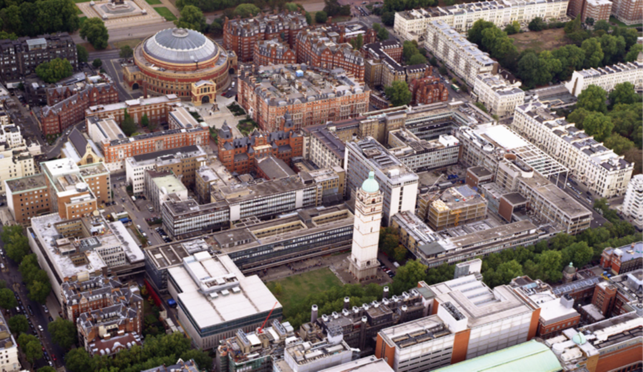

Formation and History

Established in 1907 in London’s scientific and cultural heartland in South Kensington, the College was initially formed through a merger of the Royal College of Science, the City and Guilds College and the Royal School of Mines.
The Faculty of Medicine and Imperial College School of Medicine resulted from the merging of St Mary’s Hospital Medical School, the National Heart and Lung Institute, Charing Cross and Westminster Medical School, and the Royal Postgraduate Medical School. More recently, Imperial College Healthcare, the UK’s first Academic Health Science Centre (AHSC), was established. The College is also a founding partner of the Francis Crick Institute, an inter-disciplinary medical research institute, opened in 2016.
The Business School is another key player, offering a full range of courses and degrees, and conducting research that benefits from being in the world’s leading financial and business capital. It consistently ranks in the top five Business Schools in the UK and Europe, and top ten worldwide.
Location

The College has one of the largest university estates in the UK, with seven London campuses and one outside London:
- South Kensington - the main campus, set in a cultural centre known for arts, science and music;
- Five hospital campuses at Charing Cross, St Mary’s, Chelsea and Westminster, the Hammersmith and the Royal Brompton;
- White City – a new campus and an innovation and translation hub for collaborative, multi-disciplinary research, postgraduate study, housing state-of-the-art facilities, as well as student accommodation.
- Silwood Park - outside London, near Ascot, this postgraduate campus, set in 250 acres of natural parkland, housts Ecology, Biology and the Grand Challenges in Ecosystems and the Environment initiative.
Facts and Figures

The College:
- is home to 17,000 students and 8,000 staff (half of whom are research and academic staff);
- ranks consistently in the top 5 universities in Europe and top 10 worldwide;
- awards around 6,700 degrees annually;
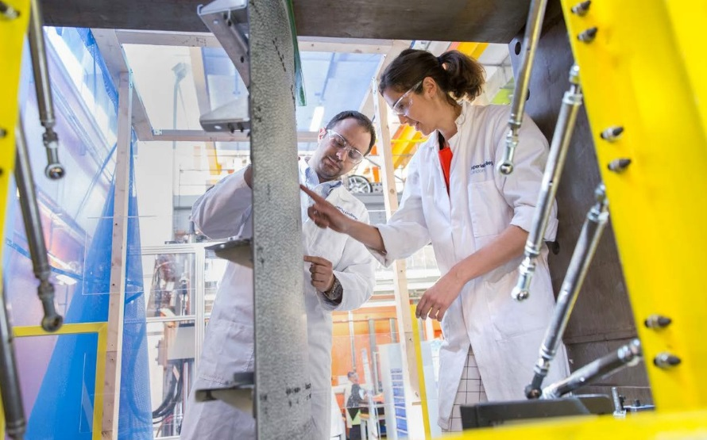
- attracts undergraduates from over 125 countries and staff with 117 different nationalities;
- Places excellence in education at the core of its ethos, as reflected in annual UK and international rankings. Find out how Imperial performed most recently
- Has the greatest concentration of high-impact research of any major UK university. More about how the College performed in the Research Excellence Framework;
- has one of the highest incomes in the UK Higher Education sector;
- holds an Institutional Silver Athena Swan award, recognising women's academic careers in science, technology and engineering
- claims many distinguished members, including 14 Nobel laureates, two Fields Medallists, and members of the Royal Society and National Academies.

Research, Translation and Impact

The quality of the College’s research has been judged consistently to be of the highest international standard and the proportion of income from research grants and contracts is one of the highest of any UK university.

The concentration and strength of research in science, engineering, medicine and business gives the College a unique and internationally distinctive research presence. Interdisciplinary institutes at the College provide a focal point to harness research that seeks solutions to grand challenges, such as improving global health, tackling climate change, finding sustainable sources of energy and addressing security challenges.

The Research Excellence Framework (REF) 2014 marked the College’s best ever performance in a national research assessment. In addition to having the greatest concentration of high-impact research in the UK, eight out of fourteen areas assessed are top or joint-top for “outstanding” or “very considerable” impact; 91% of the research is “world-leading”; nine of fourteen research areas were in the top three, and two took the top spot, namely: Public Health, Health Services and Primary Care, and Civil and Construction Engineering. Finally, 92% of eligible staff took part in the assessment, one of the highest proportions of any UK university.
International collaborations provide further opportunities, and include the College’s Diabetes Centre in Abu Dhabi, and Biobank Qatar, a unique initiative to establish the largest population-based study in the region addressing chronic diseases.

The College’s entrepreneurial drive to produce world-class research with optimum impact has resulted in many recent initiatives such as the DNA Synthesis and Construction Foundry which uses synthetic biology technology to address global problems, the Centre for Blast Injury Studies, the Dyson School for Design Engineering and the Data Science Institute. The Brevan Howard Centre for Finance opened in 2014 to spearhead cutting-edge research in financial market behaviour and serves as a bridge between the Business School and the business world.

Effective commercialisation of intellectual property is central to the College’s aim to maximise the impact of its research. Imperial Innovations commercialises technologies and discoveries emanating from the College. The College continually seeks out and develops links with industry and engages in corporate partnerships to maximise opportunities, synergies, and research translation.

The College is a proud signatory to the San-Francisco Declaration on Research Assessment (DORA), which means that in hiring and promotion decisions, we are determined to evaluate applicants on the quality of their work, not the journal impact factor where it is published. For more information, see https://www.imperial.ac.uk/research-and-innovation/about-imperial-research/research-evaluation/


Learning and Teaching

Students are immersed in a stimulating learning environment that encourages them to look beyond their chosen discipline. Education opportunities offering insights into global issues and fostering group working are open to all undergraduates, broadening their team working skills and business understanding and equipping them for their future careers. Over a third of students are postgraduates.

The Graduate School is the focus of postgraduate education and research; it maintains, enhances and monitors quality, best practice, and initiates new programmes particularly those with an interdisciplinary slant. The postgraduate provision uses work-based training, and first-hand experience of new and emerging research to prepare students for the job market. Many courses are multidisciplinary.

The College’s most recent Education and Student Strategy (2013) is a comprehensive five-year plan to achieve international recognition in four areas: as a global community of the most talented students; for commitment to innovation in learning and teaching and in the wider student experience; for providing a distinctive education; for outstanding academic and professional service infrastructure.

The Centre for Educational Development raises the profile of, and underpins learning, teaching and educational development throughout the College. Newly-appointed non-clinical lecturers are expected to develop and expand their teaching skills, and there are many learning and teaching activities for more experienced staff.


The College continually seeks to engage with, and establish collaborations with other organisations to take advantage of research opportunities and synergies, as well as expanding its influence in education. In 2013 the College formed a joint initiative with Nanyang Technological University in Singapore to open the Lee Kong Chian School of Medicine. Each year, 750 students will enroll in Medicine and 2018 will the first intake graduate.

Supporting our Staff

The College is very proud of its staff, of their many talents, contributions to world class research and to teaching some of the brightest students in the world. We offer extensive support for them to pursue their research including Faculty-based research services teams, central strategy, research proposal and intellectual property guidance, scholarly communication and open access and research data management. Teaching and postgraduate supervision is also strongly supported and continuously strengthened, through training programmes and workshops.

The President’s annual awards for Excellence in Research, Excellence in Teaching, Pastoral Care, Research Student Supervision, and Supporting the Student Experience recognise those who have made outstanding contributions. Some of the ways we offer a supportive environment include:

Pride in the work of our staff and the College:
- An inclusive, supportive, multi-cultural community where every individual feels that they belong
- A community where all interactions are respectful and where every role is recognised as being important to the College's mission

The development of staff and their high performance potential:
- An academic promotion framework to recognise academic success and growth in roles, specialist expertise and responsibilities
- Talent programmes to support progression and strengthen existing high performance, such as the Academic Leadership Programme and the Female Academics’ Development Centre which offers targeted support, career guidance and mentoring
- A skills development programme to enhance potential and meet the College’s strategic objectives
- Faculty-specific learning and teaching development programmes
- An annual personal review and development discussion for all staff, followed by regular feedback
A minimum of five days per annum development time tailored to an individual's role and career path

Sector leading pay and benefits:
- A competitive pay and benefits package, commensurate with our position as a leading UK University, as well as and has a generous annual leave package.

Support for well-being:
- Many initiatives to support staff in their personal life (flexible working, support networks, childcare and eldercare) as well as active lifestyle and health initiatives, such as free health checks for over 50s and interest free loan for the purchase of a bicycle to encourage cycling to work for fitness.


Committed to equality and valuing diversity, we are an Athena SWAN Silver Award winner, a Stonewall Diversity Champion, a Disability Confident Employer and work in partnership with GIRES to promote respect for trans people.

Faculty of Engineering

The Faculty of Engineering is one of three faculties within Imperial College London and is led by the Dean, Professor Nigel Brandon OBE FREng. The Faculty seeks to provide international leadership in engineering research and education and is widely recognised as a world-leading engineering school. In the Times Higher Education World University Rankings 2014-2015 the Faculty was ranked 2nd in Europe and 6th in the world for Engineering and Information Technology. Our Faculty is unique in the UK in supporting world-class education and fundamental research across the full range of engineering disciplines. All ten of our academic departments are located on a single campus in South Kensington, giving a concentration of talent that creates a stimulating and vibrant research culture which promotes multidisciplinary collaborations and attracts internationally leading researchers and scholars.

Our academic departments deliver world-class education in engineering in order that our graduates possess the skills, knowledge and attitudes necessary to become international leaders in engineering industry and academia. We provide our students with an outstanding engineering education that brings together cutting edge researchers, exceptional teachers and state-of-the-art facilities in inspiring physical and virtual environments. Students at Imperial will meet, work and live with people studying every aspect of engineering.

The Faculty is home to 1,575 staff (395 academics, over 800 researchers and 365 support staff) and 5,785 students (of who 1,200 are research students). The Faculty is a powerhouse in research across the engineering sciences, with research funding in excess of £100M per annum.
Please see the Faculty of Engineering web pages for further information: http://www.imperial.ac.uk/engineering

Department of Computing

The Department of Computing at Imperial is one of the largest computing departments in the UK and is a world leader in academic research in computer science. We aim to remain among the leading departments in the world for research and education in our discipline. To ensure our place, the objectives of the Department are:

- To pursue research excellence and innovation in core Computer Science.
- To carry out world-leading interdisciplinary research which recognises that Computer Science is pervasive in all areas of society.
- To develop novel, sound and applicable computing techniques to meet the evolving needs of science, industry and society.
- To pursue innovative education based on foundational research that fosters technical excellence, originality and breadth of vision in its students.
The Department is embedded in the largest Engineering Faculty in the country, with all academic departments being located on a single campus. This concentration of talent across Computing and Engineering as a whole creates a stimulating and vibrant research culture that promotes multidisciplinary collaborations and attracts internationally leading researchers and scholars.
The Department comprises 65 academics, 42 support staff and around 140 research staff. The student population is around 600 undergraduates, 200 MSc students and 180 PhD students. The Department has extensive and well-equipped computing laboratories and runs its own computing service for research and teaching. In REF 2014, the most recent assessment of UK research, the Department was rated as the top Computer Science department in both Research Environment and Research Intensity and our teaching is always rated in the top three in the newspaper and good university tables.
Research is structured around the research themes of: Distributed Software Engineering; Logic and Artificial Intelligence; Programming Languages and Systems; Quantitative Analysis and Decision Science; Visual Information Processing. We are part of the Faculty of Engineering and have joint appointments with the Department of Bioengineering and the Department of Electrical Engineering.

The Department encourages interdisciplinary work and is a major partner in the Institute for Security Science and Technology, the Data Science Institute, the Hamlyn Centre for Medical Robotics, the Centre for Integrative Systems Biology at Imperial College (CISBIC), the Syngenta University Innovation Centre on Systems Biology at Imperial College.
We have strong links with industry, which helps to ensure that our research and teaching is well informed and relevant to the needs of society. Major industrial partners include: ARM, Dyson, Facebook, Google, Huawei, IBM, Imagination, Intel, Microsoft, NEC, Ocado, Orange Labs and VMWare.
The Department offers the following undergraduate degree programmes: a three-year BEng degree in Computing; a four-year MEng degree in Computing with the option to specialize in Software Engineering, Artificial Intelligence, Computational Management, International Programme of Study. There is also a three-year BEng degree in Mathematics and Computer Science and a four-year MEng degree in Mathematics and Computer Science with the option to specialize in Pure Maths and Computational Logic, or Computational Statistics.

The Department runs an MSc in Advanced Computing and a more generalist MSc in Computing Science. The Department also runs a wide range of specialist MSc programmes in Artificial Intelligence, Machine Learning, Computational Management Science, Security of Software Systems, Software Engineering, and Visual Information Processing.

The Department encourages innovation in all aspects of teaching and is willing to provide resources to help implement novel approaches and ideas, subject to budget constraints and approval by the Teaching Committee. Outstanding contributions to teaching quality are recognised both at Faculty and College level through annual teaching awards.

DEPARTMENT OF COMPUTING

Four Lecturers / Senior Lecturers in Computer Science

Title of Post: Lecturer / Senior Lecturer

School/Institute/Department: Computing

Main site of activity: South Kensington Campus

Responsible to: Head of Department

Salary range: Lecturer – Level C £47,910-£53,400
Senior Lecturer – Level D minimum £58,870

Level: Academic and Research, Level C / D

The Post

The Department of Computing at Imperial College London invites applications for full-time, faculty members at the Lecturer/Senior Lecturer level (comparable to tenure-track Assistant/Associate Professorships) who can contribute to research and teaching, in particular in the following areas:

- Artificial Intelligence (including autonomous systems, multi-agent systems, knowledge representation and reasoning, logic-based AI, planning and natural language processing);
- Machine Learning (including probabilistic models, approximate inference, reinforcement learning, deep learning, optimization, computational learning theory and probabilistic programming);
- Cyber-physical Systems (including sensing systems and networks, embedded systems, Internet-of-Things and wearable computing);
- Robotics (including all aspects of machine intelligence, perception and interaction, robot vision, navigation, planning, manipulation, human-robot interaction and virtual & augmented reality).

Notwithstanding the above focus, exceptional candidates from any area of Computer Science are also encouraged to apply.

Post holders are expected to have a proven international record in their research area and will be expected to play a full part in the teaching and administrative activities of the Department.
The posts are within the Department of Computing at Imperial College London, South Kensington Campus. Further information about the Department can be found at the following web site: http://www.imperial.ac.uk/computing.
Research

- Undertake original research at the highest international standard;
- publish the results of this research in internationally recognised, peer-reviewed journals;
- present the results of this research at international scientific and professional conferences;
- establish an international research profile;
- raise research grants and contracts from industry, Research Councils and other national and international funding agencies.

Teaching

The post holder will be expected to be capable of contributing to the Department’s undergraduate and Master’s course teaching across a wide spectrum of lecture courses. The post holder will teach and examine courses to all levels including undergraduate, master’s and higher research degree students through lectures, seminars, course work, tutorials and personal supervision. The post holder will be required to prepare and deliver lectures to classes of up to 200 students in any of the four years of the undergraduate course. In addition, because the Department’s teaching places great emphasis on project-based design and laboratory work, the post holder will be involved in the supervision of laboratory and/or design groups. All Lecturers in the Department are required to attend training courses in teaching methods and course design, unless they can demonstrate existing qualifications. The appointee will be required to:
- plan and review his or her own approach to teaching;
- contribute to the development of teaching, teaching methods and assessments in the Department to enhance the quality of teaching;
- develop approaches to teaching which are innovative and reflect best practice developing elsewhere;
- develop course proposals and contribute to curriculum development;
- supervise research projects at both undergraduate and master’s levels.

Administration

Undertake such academic administrative duties within the Department, and the College, as the Head of Department may require. These will include:
- acting as personal tutor to Undergraduate students;
- serving as an examiner at Undergraduate, Masters and PhD level;
- interviewing potential students;
- serving on appropriate departmental and College committees.

In leadership, management and supervisory roles, new members of staff will be required to familiarise themselves with Imperial’s Expectations, which will help them fulfill their role at the College. More information can be found at the following web page: http://www3.imperial.ac.uk/hr/procedures/support.

To observe and comply with all College policies and regulations, including the key policies and procedures on Confidentiality, Conflict of Interest, Data Protection, Equal Opportunities, Financial Regulations, Health and Safety, Imperial Expectations (for new leaders, managers and supervisors), Information Technology, Private Engagements and Register of Interests, and Smoking.

To undertake specific safety responsibilities relevant to individual roles, as set out on the College Website Health and Safety Structure and Responsibilities page (http://www.imperial.ac.uk/safety).

Job descriptions cannot be exhaustive and the post-holder may be required to undertake other duties, which are broadly in line with the above key responsibilities.

Post holders are expected to observe and comply with all College policies and regulations, for example, Health and Safety, financial regulations, data protection, etc.

Imperial College is committed to equality of opportunity, equal treatment and to eliminating discrimination. All employees are expected to adhere to the principles set out in the Equal Opportunities in Employment Policy, Promoting Race Equality Policy, Disability Policy, Gender Equality Policy, and all other relevant guidance and good practice frameworks.

Person Specification

Applicants are required to demonstrate that they possess the following attributes:

Imperial Expectations
These are the 7 principles that Imperial leaders, managers and supervisors are expected to follow:
- Champion a positive approach to change and opportunity
- Communicate regularly and effectively within, and across, teams
- Consider the thoughts and expectations of others
- Deliver positive outcomes
- Encourage inclusive participation and eliminate discrimination
- Support and develop staff to optimise talent
- Work in a planned and managed way

Knowledge and Experience

- A PhD (or equivalent) with research experience in an area of Computer Science.
- A proven track record in conducting high-quality research, as evidenced by publications in peer-reviewed journals.
- The potential to contribute to the delivery of undergraduate and postgraduate teaching programmes offered within the Department.
- The potential to undertake original research and to publish at the highest international level.
- The potential to raise significant research funding from a variety of sources including UK Research Councils.
- The capability to attract high quality research students.

Skills and Abilities

- The ability to communicate well, conveying ideas and concepts clearly and effectively to undergraduate, postgraduate and professional levels.
- A high level of analytical capability, with the potential to provide scientific leadership.
- The potential to make a contribution to some of those administrative requirements within the Computing Department associated with the candidate’s teaching and research areas.

Salary and Conditions of Service:

The salary range for a Lecturer is £47,910-£53,400 per annum and for a Senior Lecturer the minimum salary is £58,870 per annum.

Lecturer posts will be graded at Level C in the Academic and Research Job Family and Senior Lecturer posts will be graded at Level D in the Academic and Research Job Family. First increments for those staff will be paid according to their start date, i.e., on 1 October following appointment if appointed between 1 October and 31 March inclusive, and on the first of the month following six months’ service if appointed between 1 April and 30 September inclusive.

Incremental progression and any performance payments will be determined in accordance with procedures governing all Level C in the Academic and Research Job Family. Annual cost of living increases will be determined by Imperial College through its local collective bargaining machinery.

A full set of terms and conditions will be given to the successful candidate, together with the College’s most important policies which affect staff. The principal terms and conditions are as follow:

Conditions of Service:

Salaries are payable on the 24th day of each month (the exception being December) by transfer to a bank or building society account. Deductions in respect of income tax and National Insurance contributions will be made from salaries at the statutory rates.

Academic staff normally take annual leave during College vacations and by arrangement with the Head of Department in the light of academic and departmental requirements. Annual leave entitlement is 39 days for full time staff (pro rata entitlement for part time staff). This is inclusive of 8 days for Public holidays and a total of six days each year when the College is closed over Easter and Christmas.

In some years, because of the day of the week on which Christmas day falls, a decision may be made to increase the College closure to seven days. In these circumstances the annual leave entitlement will be increased to 40 days for full-time staff (again pro-rata for part-time staff).

At the beginning of the leave year staff will be required to allocate the appropriate number of days of their mandatory leave entitlement to cover the College Closure days and Public holidays that fall within that leave year. For part-time staff the allocation should cover their normal working days that fall upon a College closure day, bank or public holiday during that leave year.

The College Closure days and Public Holidays are listed on the HR website.

The occupational pension scheme is the Universities Superannuation Scheme (USS). Staff who are already members of the Federated Superannuation System for Universities (FSSU) or the National Health Service Superannuation Scheme (NHSPS) may, if they are still eligible, retain their membership in these schemes.

Unless stated otherwise in the offer of employment, or agreed by the head of department, the appointment may be terminated by either side by giving a minimum of three months’ notice in writing. The last day of service should fall on one of the following dates: 31 December; 31 March; 30 June or 30 September or at the end of a term by agreement with the Head of Department.

All appointments have a probationary period of six months, or, in the case of Lecturers and Senior Lecturers (clinical or non-clinical), a training and development review period, which lasts 3 years for non-clinical Lecturers, and 5 years for clinical Senior Lecturers.

Staff on fixed term contracts receive notice of the ending of their employment within that contract. No further contractual notice will be given unless the contract is to terminate prior to the end date specified in the offer of employment. In these circumstances the notice from the College would be as above.

Applications

Our preferred method of application is online via our website, please go to http://www.imperial.ac.uk/job-applicants/ and search using vacancy reference number ENG00005.

In addition to completing the online application, candidates should attach:

- A full CV including a publication list.
- A list of the four most significant publications. For each of the four publications please include a short statement (100 words maximum) highlighting the key contributions made by the applicant in that work.
- A research statement that describes your previous research contributions and future research plans (no more than two pages).
- A teaching statement that describes your previous teaching experience and potential contributions to teaching in the Department (no more than two pages).

Applicants should contact three referees before applying to ensure their willingness to provide a reference for the present post.

For queries regarding the application process, applicants should contact Mrs Margaret Hall: margaret.hall@imperial.ac.uk

Imperial Expectations guides the behaviour of all our staff.

Closing date: 18th December 2017 (Midnight GMT)

Oct 2017

